GUJARAT TECHNOLOGICAL UNIVERSITY

CHANDKEHDA, AHEMDABAD

VISHWAKARMA GOVERNMENT ENGINEERING COLLEGE

(Affiliated with Gujarat Technological University, Ahmedabad) A PROJECT REPORT ON

**ALL ABOUT ORGANIZATION**

Prepared as a part of the requirement for the subject of

B.E- Semester- 5 (Computer engineering)

|  |  |  |
| --- | --- | --- |
| Submitted by:  **Sr. No.** | GROUP ID:- 180350  **Name** | **Enrollment No.** |
| 1 | KHUSHNOOD SHAIKH | 180170107110 |
| 2 | RUTVIK PATEL | 180170107085 |
| 3 | RUSHI PATEL | 180170107084 |

### Guided by:

**Prof. J. B. BHATIA**

Assistant Professor, Computer Engineering, VGEC, Chandkheda

### Head of department:

**Prof. M. T. SAVALIYA**

Professor & Head, Computer Engineering, VGEC, Chandkheda

### Academic Year

2020-2021

### DEPARTMENT OF COMPUTER ENGINEERING

**Vishwakarma Government Engineering College, Chandkheda**

Opp. Sangath Mall, Visat-Koba Road, Chandkheda, Ahmedabad

**Email:[hod_ce@vgecg.ac.in](mailto:hod_ce@vgecg.ac.in) Website:**:https://[www.vgecg.ac.in](http://www.vgecg.ac.in/)

**CERTIFICATE**

# This is to certify that the Project II A (3150001) Report entitled

“ALL ABOUT ORGANIZATION”

Submitted by :

**Sr. No. Name Enrollment No.**

1. KHUSHNOOD SAIKH 180170107110
2. RUTVIK PATEL
3. RUSHI PATEL

180170107085

180170107084

We towards the partial fulfilment in Project I (3140005) (Computer Engineering) of Gujarat Technological University is the record of work carried out by him under our supervision and guidance in the Academic Year 2019-20.

The work submitted has in our opinion reached a level required for being accepted for examination. The results embodied in this Project Work to the best of our knowledge have not been submitted to any other University or diploma.

**Guided by:**

**Prof. J. B. BHATIA**

**Assistant Professor,** Computer engineering, VGEC,

Chandkheda – 382424

**HoD** :

**Prof. M. T. SAVALIYA**

**Professor & Head,** Computer Engineering, VGEC,

Chandkheda – 382424

## ABSTRACT

The “ALL ABOUT ORGANIZATION” aim of this project to provide the accurate information about NGOs, Charitable Trusts, Government Organizations and an online platform to social groups having less resources.

This online web project will list out different organization with their field of social work i.e. child labor, woman empowerment, education etc. and their location of work. We will give rating to each organization based on their work quarterly. This web – based project with secure payment gateway will ensure that your money will reach to the right destination. This website will have volunteering portal which help individuals to work with their nearest NGO organization.



## ACKNOWLEDGEMENT

With great pleasure, I take this opportunity to express my deep sense of gratitude and indebtedness to my renowned and esteemed guide **Prof. J. B. BHATIA** Assistant Professor, Department of Computer Engineering, Vishwakarma Government Engineering College, Chandkheda for his consummate knowledge, due criticism, invaluable guidance and encouragement which has enabled us to give present shape to this work.

I am heavily indebted to **Prof. M. T. Savaliya**, Professor & Head, Department of Computer Engineering, Vishwakarma Government Engineering College, Chandkheda, for his everlasting willingness to extend his profound knowledge and experience in the preparation of this report. Any attempt to define this indebtedness would be incomplete. I am immensely thankful to **Dr. N. N. Bhuptani**, Principal, Vishwakarma Government Engineering College, Chandkheda, for her valuable support and inspiration.

I am immensely thankful to **Prof. AMIT RATHOD,** Associate Professor, Computer Engineering Department, VGEC Chandkheda – Ahmedabad for his everlasting willingness to extend his support and help in the completion of this work.

**CONTENTS…** Page No.

1. Introduction 7
2. Canvases 8
   1. A-E-I-O-U Canvas 8
   2. Mind Mapping  10
   3. Product Development Canvas  12
   4. Empathy Canvas 14
   5. Ideation Canvas 16
   6. LNM Canvas 18
3. Prototype 19
4. Methodology 23
5. Conclusion and Future Work 24
6. References 25

**Table Of Figures**

|  |  |  |
| --- | --- | --- |
| FIGURE NO. | FIGURE NAME | PAGE NO. |
| 2.1 | AEIOU CANVAS | 9 |
| 2.2 | MIND MAPPING CANVAS | 11 |
| 2.3 | PRODUCT DEVELOPMENT CANVAS | 13 |
| 2.4 | EMPATHY CANVAS | 15 |
| 2.5 | IDEATION CANVAS | 17 |
| 2.6 | LNM CANVAS | 18 |
| 3.1 | LOGIN SCREEN | 19 |
| 3.2 | HOME SCREEN | 20 |
| 3.3 | ORGANIZATION LIST SCREEN | 20 |
| 3.4 | HELP US SCREEN | 21 |
| 3.5 | DONATION SCREEN | 21 |
| 3.6 | MOBILE VIEW HOME SCREEN | 22 |
| 4.1 | METHODOLOGY VIEW | 23 |

# Introduction

In the new online era of social networking, it will also be a good idea to mention any social profiles you have online. This can be extremely useful because if a donor agency wants to know more, it can check your details online.

NGO’s play a significant role in bringing social change in society and development of society. In different parts of the world, it has proven that these organizations have many sides. To be a member of it people need to be educated, enthusiastic and inspired.

Today, Non-Governmental Organisations (NGOs) and Nonprofits spend a lot of time doing good work, coordinating volunteers, and raising money. It is obvious that implementing various activities within the organization will require piles of paperwork, unpredictable expenses, ineffective use of time and more.

But, most of the NGOs and NPOs are unable to create their presence and reach out to right audience. The main reason for this is due to lack of presence of NGOs and NPOs in online medium.Now, creating presence in the online world in this digital era is just one click away. Today, the best way for an organisation to make its online presence is by promoting itself and its work through an online medium like a website.

In phase of this project of website for organisations and make their presence online and reach out to the potential audience we started with the mind map , canvasses and prototype(user interface) screen.

# Canvas

## AEIOU CANVAS

AEIOU is an investigative tool to help interpret observations gathered by ethnographic practices in the field. It is an Observation tool. The framework can be applied as-is or customized and adapted into a new taxonomy. Its two primary functions are to code data, and to develop building blocks of models that will ultimately address the objectives and issues of a client. AEIOU can be used in- field as worksheets or be applied later to code data collected from other ethnographic or observational methods, including notes, photos, and interviews. AEIOU stands for 5 elements to be coded: Activity, Environment, Interaction, Object, and user.

**ACTIVITY:**

This section will include the activities observed at domain which are specified as follows Charity, Donations, Social Services, Volunteering, Crowdfunding, etc.

**ENVIRONMENT:**

This will include the effect of the objects placed in its surroundings such as: One platform, Easily accessible, User friendly, etc.

**INTERACTION:**

This will include the Stakeholders which are performing the interactions such as Donors, Organizations, Volunteers, Needy people, Society individuals ,etc.

**OBJECTS:**

This section of the canvas includes the equipments observed at the domain such as Information Portal, Payment Gateway, Accurate Information,etc.

**USERS:**

As usual it will include the people who are associated with the service like Society Individuals, Trustees, Donors, Volunteers, etc.

## C:\Users\Anam Shaikh\Desktop\111.png

**FIGURE 2.1 : AEIOU CANVAS**

## MIND MAPPING

Mind maps works as a visual and graphical tool to help structure information, analyse complicated concepts, recall and generate new ideas. A mind map is a visual tool used to organize information graphically. It is hierarchical and represents relationships among parts of the whole. A mind map usually begins with a single concept, then drawn as an image in the center of a blank page, where associated representations ideas will be added, such as words and images. Main ideas will be connected directly to the central concept, and other sub topics branch out from the major ones.

You can include drawings, questions, comments, solutions, problems, etc. There are no limits. Simply write down everything that relates to the central theme or anything that enters your mind. All that mind mapping really is, however, is a

way to get all of the ideas in your head down onto paper. There is no right or wrong way to mind map. It is simply a visual representation of the thoughts in your head, and it often looks like organized chaos.

Mind mapping helps you to release all of the ideas in your head and gives you the opportunity to see those ideas visually. It is a fast and simple way to get your creative juices flowing, and the only tools you need are a pen or pencil and your design notebook.Mind maps are similar to spider diagrams because of the layout of their major ideas and sub ideas. People can create a mind map by hand as rough notes for an urgent meeting or lecture ; they can also use a specialized mind mapping program  for more professional situations.

To start a mind map, write down one, central idea or theme in the middle of a blank page. All mind maps have this common starting point. Then, stem off of the central idea by writing down anything that comes to your mind when thinking about the idea. You can create a mind map at any stage in your design process and for absolutely any purpose. You can mind map at the very beginning before you have even decided what problem you are going to solve.

You can also mind map to generate possible solutions to your problem or to identify different types of users for your project. Mind map whenever you feel the need to empty the thoughts in your head or whenever you feel stuck during the design process.

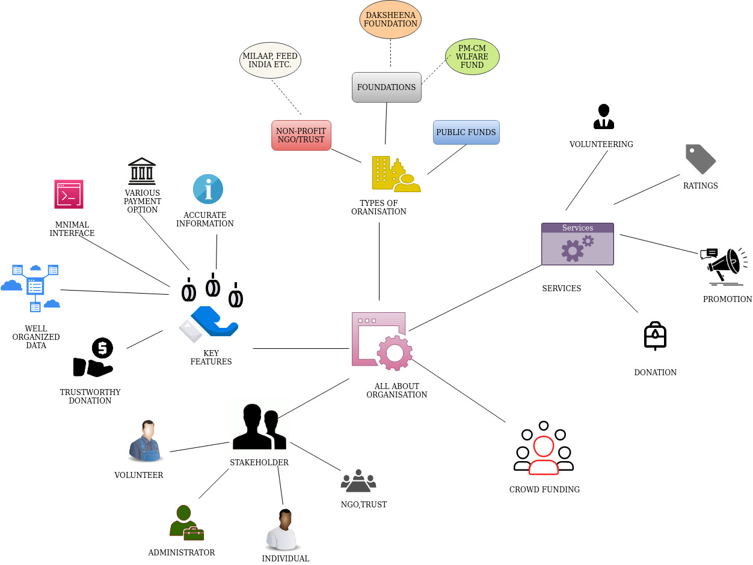

**FIGURE 2.2 : MIND MAPPING CANVAS**

This mind map canvas shows various fields such as types of organization, key features, services, stakeholders, crowdfunding, etc. Each further divided into its fields, elaborating it.

## 2.3 PRODUCT DEVELOPMENT CANVAS

The Product Canvas is oriented towards the functionality of a pin board. All information about the planning process will be summed up in the provided areas.

**PURPOSE:** The purpose of the given project is as follows :

* Authentic Information
* One Platform
* Easily Accessible
* Avoid Frauds

**PEOPLE:** The most basic users of such kind of products are public.. Next comes a Student as he/she will use to study and practice so that they can improve the future of next generation. After that there are various users such as;

* Donors
* Volunteers
* Individuals

**PRODUCT FEATURES:** The most important feature of this is;

* Well Designed Components
* Easy Exploration
* Accurate Information

**PRODUCT FUNCTIONS:** The most important and basic functions of these products are:

* Good UI/UX
* Efficient
* Faster
* Secure Payment Gateway

**CUSTOMER REVALIDATION:** Here comes the very important part of developing any product, Customer Revalidation. As to decide that the product is successful or not Customer Satisfaction is must. Now image below shows the customer reviews and ratings on various aspects of the product.

* Time saving
* Responsive Website
* Fast Payment

**REJECT, REDESIGN, AND RETAIN:** After pondering on customer revalidation the following points can be revisited:

* Compatible With All Devices

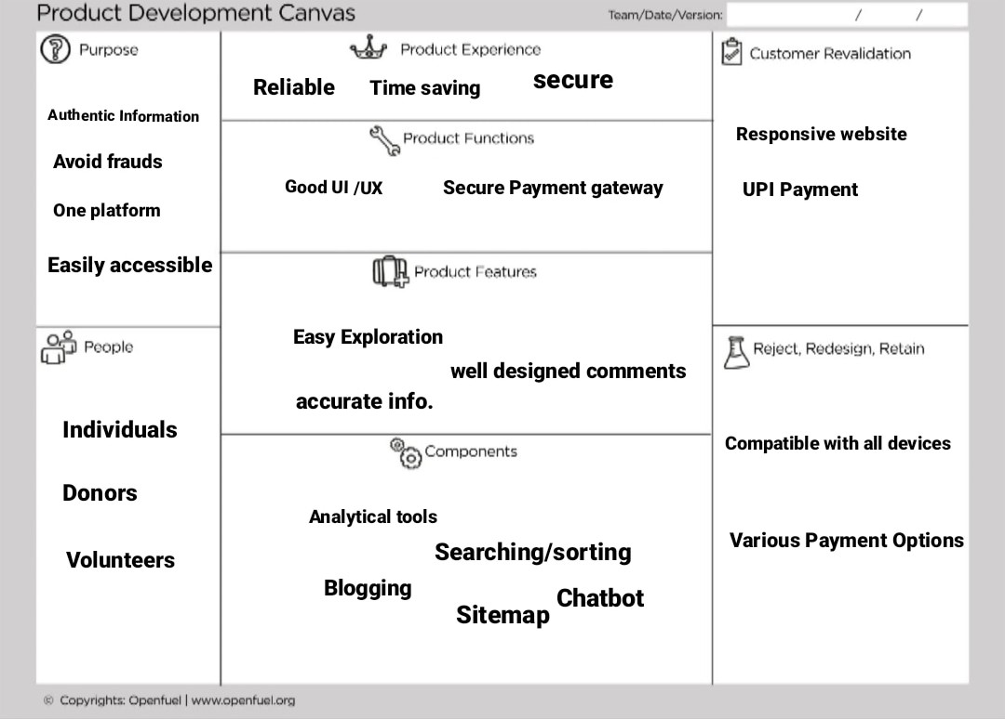

**FIGURE 2.3 : PRODUCT DEVELOPMENT CANVAS**

## 2.4 EMPATHY CANVAS

This is the first step of the project or a problem. In this canvas, we will find out what is user? Who is a User? What is Stakeholder? Who are they? And what are the broad stories of their activities?

**User:** In this stage, we find various users who are directly or indirectly related to our product .For Example: Society individuals, Volunteers, Donors, etc.

**Stakeholders:** Stakeholders are people or an organization with an interest. In this stage, we find those users which are directly or indirectly related to the users. For Example: Trustee, Managers, Grantsmanship, Foundations, etc.

**Activities:** Activities are directly or indirectly related to the stakeholders. For Example:  Crowdfunding campaign, Volunteering, Excessive internet surfing, charity, etc.

**Storyboarding:**

* + - **Happy:** A ngo who helped migrant workers in lockdown gets help from crowdfunding campaign so they helped those needy in this situation.
    - **Happy:** Workes who depends on daily wages gets food from an initiative of youngsters, they arranged the basic needs with help of online funding.
    - **Sad:** One person wants to donate to pm cares funds but frauds have created fake UPI Id , so people find there donations handed to frauds.
    - **Sad:** One person despite of donating money to organisation he didn't get information of his donations, where his funds used.

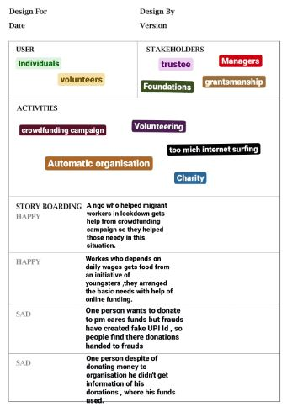

**FIGURE 2.4 : EMPATHY CANVAS**

## 2.5 IDEATION CANVAS

This canvas consists of the ideology behind the user, so in this canvas some brief ideas are expressed. People section consists of persons related to user technically and similar persons may relate to user. Then we divided activities in social & technical and try to find out the importance of each activity and situations & location regarding are find out related to each.

Ideation is often the  most exciting stage in Design Thinking project, because during ideation , the aim is to generate a large quality of ideas that the team can then filter and cut down into the best, most practical or most innovative ones in order to inspire new and better design solutions and products.

### PEOPLE:

* + - Trustee
    - Individuals
    - Donors

### ACTIVITIES:

* + - Crowdfunding
    - Social services
    - Charity
    - Volunteering

From different activity & situation the “key problem” can be defined which is the most important problem than other problems vivid situations & location from key problem must be very important, critical problem from user point of view. Here in this case the problems we faced are as given below:

### SITUATION:

* + - Fake UPI ID Frauds
    - Wrong information leads to money loss

### OBJECTS:

* + - Secure payment gateway
    - Authorized donors

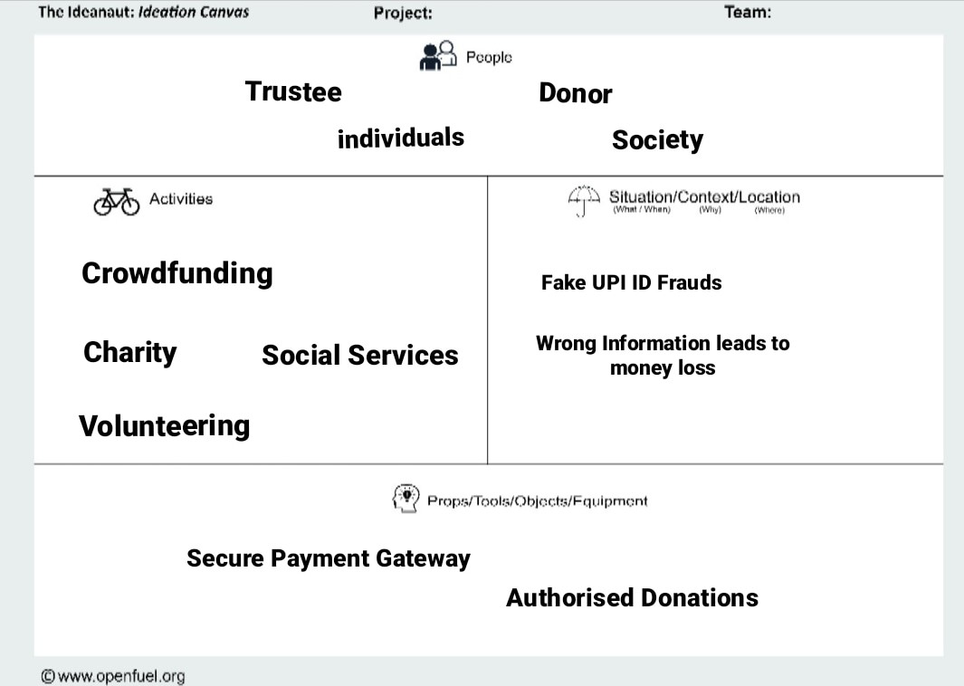

**FIGURE 2.5 : IDEATION CANVAS**

## 2.6 LNM CANVAS

The purpose of LNM is to identify the requirements of learning among the team members. While a new product/process is under development based on a unique idea (to reduce the level of difficulty faced by a user), the team members need to learn and explore a lot of new skills and documents, methods and guidelines.

The LNM is containing a quadratic layout. From centre (the concept under development), it needs to have mention of learning/exploring requirements in each quadrant representing a specific type of skill acquisition. These quadrants have a timeline associated with it that can be considered in the year of studies (II, III and IV) or phases as (short-term, mid-term and long-term). Each identified requirement of learning is connected depending upon interdependencies and paths are to be drawn. The team members can develop their own learning path to contribute to the efforts of the team for developing the concept underlying at the centre of the LNM.

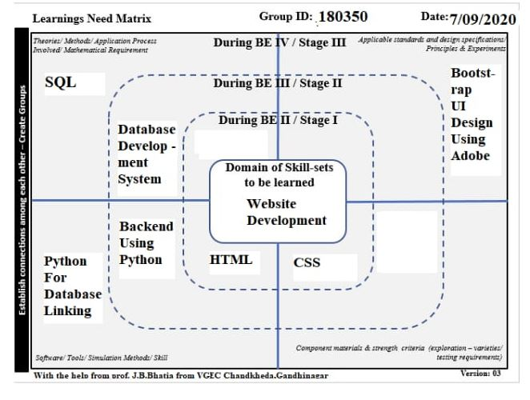

**FIGURE 2.6 : LNM CANVAS**

# PROTOTYPE:

The following prototype is an early sample or release of a product built to test a concept or process.  Prototyping serves to provide specifications for a real, working system rather than a theoretical one .A proof of principle prototype serves to verify some key functional aspect of the intended design, but the usually does not have all the functionality of final product. The given  prototype suggest well user experience .

**SCREEN 1 :** Login with your email-id.

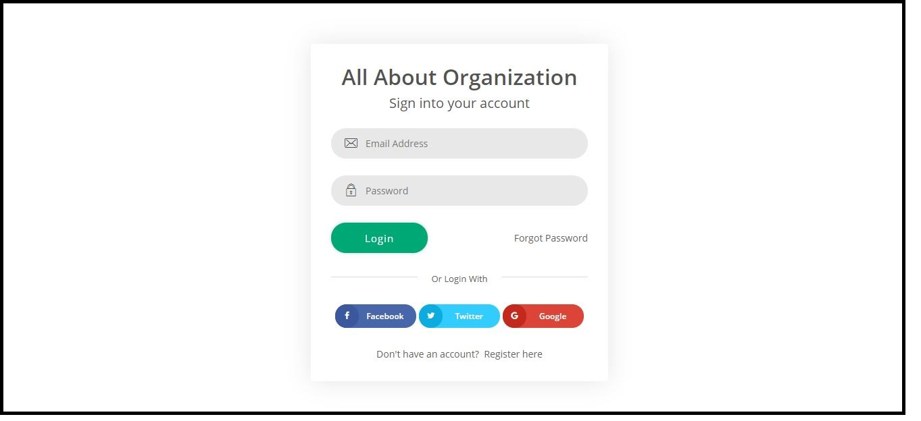

**FIGURE 3.1 : LOGIN SCREEN**

**SCREEN 2 :** View all details regarding the services provide.

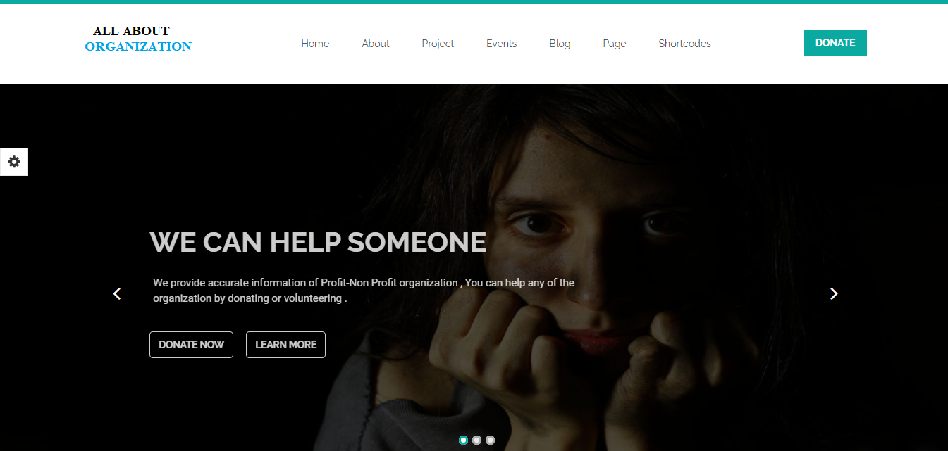

**FIGURE 3.2 : HOME SCREEN**

**Screen 3 :** Displays the lists of organizations.

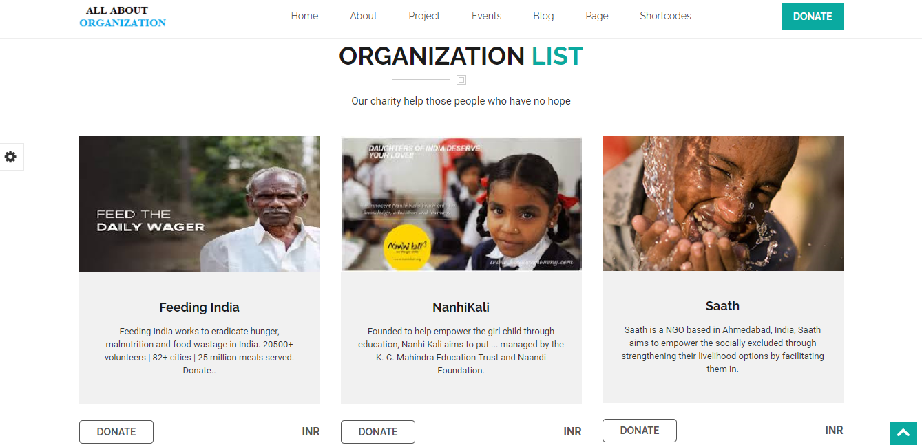

**FIGURE 3.3 : ORGANIZATION LIST SCREEN**

**Screen 4:** Shows the functionalities of website.

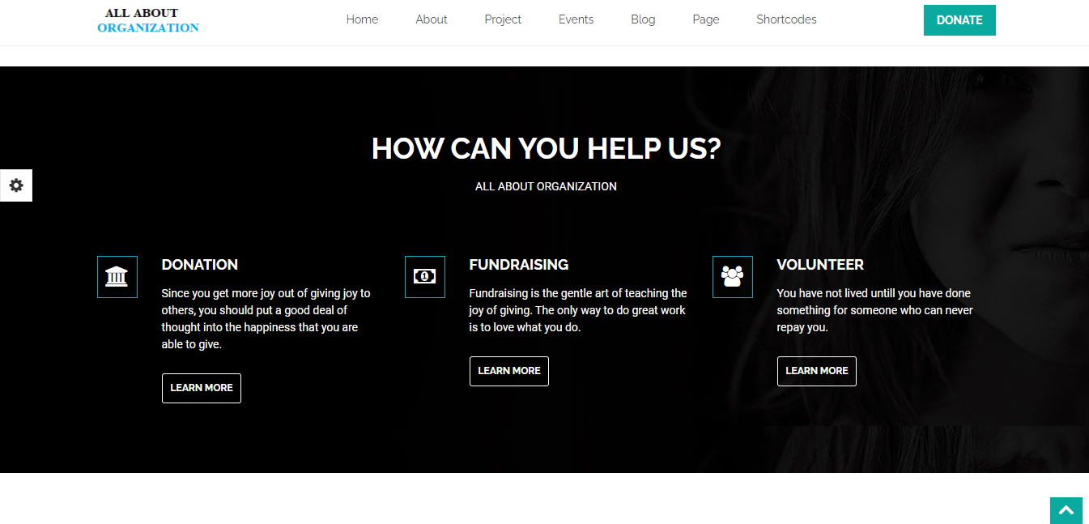

**FIGURE 3.4 : HELP US SCREEN**

**Screen 5:** Shows screen for donations.

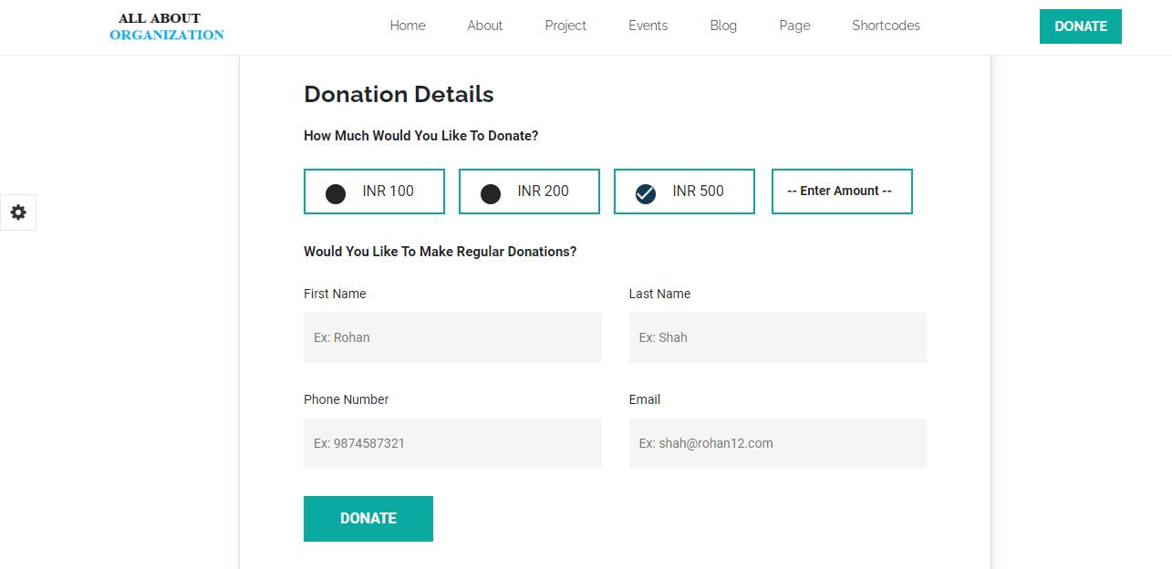

**FIGURE 3.5 : DONATION SCREEN**

**Screen 6:** Shows the mobile view of home screen.

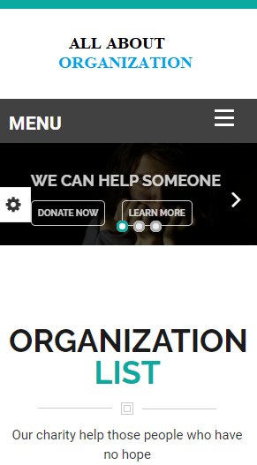

**FIGURE 3.6 : MOBILE VIEW**

**HOME SCREEN**

# METHODOLOGY

Waterfall is the most conventional software development methodology. In fact, it has been one of the most popular approaches for web development projects for several decades due to its plan-driven approach.

The Waterfall Approach Requires a lot of structure and documentation. The process is divided into several stages that form a sequence:

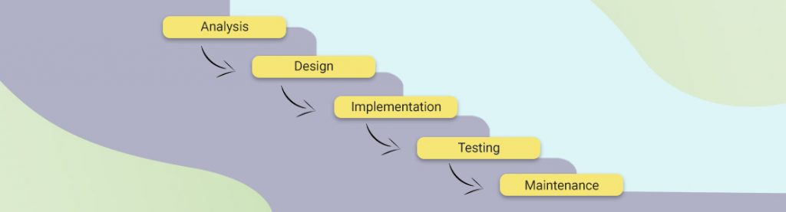The first stage is critical and requires a complete understanding of the project demands and scope both the developers and the product owner.

**FIGURE 4.1 : METHODOLOGY VIEW**

Waterfall lacks flexibility which means that every phase should be fully completed before moving forward to the next stage. Once any modifications are needed or any errors are detected during the course of the project, Waterfall will require a full restart As a result, project managed under the Waterfall method might require much more time. On the other hand, it is great for ensuring that all deliverables meet expectations and it allows for easily measuring the progress since you see the full scope of the project in advance.

Waterfall methodology is mostly used for web development projects with a clear and predefined scope, with a fixed timeframe for project completion and few iterations or revisions.

# CONCLUSION AND FUTURE WORK:

The main goal to develop adaptive Web applications from reusable, configurable, and adaptable implementation artefacts was achieved by the design and development of a declarative, document-centric component model. Its underlying XML-based description language supports the definition of document components that encapsulate both separate application aspects (content, structure, semantics, navigation, presentation) and their corresponding adaptation issues on different abstraction levels. Consequently, its expressivity and reusability goes far beyond the possibilities of conventional Web document formats. Based on a number of examples, it could be shown that the component model is applicable for implementing the most important hypermedia adaptation techniques. Furthermore, it was illustrated how document components can be automatically transformed to traditional Web document formats, adapted to the appropriate user and his usage context.

As we have done detailed prototyping, in the next phase of development we will focused on the working website based on the prototype model.

# REFERENCES :

* 1. GiveIndia – Goonj :- https://www.giveindia.org/nonprofit/goonj/
  2. Aashayein Foundation :- <https://www.aashayein.org/>
  3. KarunaTrust :- <http://www.karunatrust.com/>
  4. Nanhikali :- <https://www.nanhikali.org/>
  5. Kutumb Foundation :- <https://kutumb.in/>
  6. Child in need Institute :- <https://www.cini-india.org/>
  7. Aim for seva :- <https://aimforseva.in/>
  8. Pallium india :- <https://palliumindia.org/>